Data Validation

🧾 What Is Data Validation?
# Source: AI Source: Provided by: [Data Path: Persons Table -> ID Column: 1, Name_En Column: Motasem Essam] -> From: [ChatGPT] on [2/12/2026]
Data validation is the process of checking if input data is correct, complete, and follows required rules before using it.
👉 It ensures only valid data enters the system.

✅ Simple Definition:
# Source: AI Source: Provided by: [Data Path: Persons Table -> ID Column: 1, Name_En Column: Motasem Essam] -> From: [ChatGPT] on [2/12/2026]
Data validation is verifying that user input is accurate and acceptable.

🧠 Real-Life Analogy:
# Source: AI Source: Provided by: [Data Path: Persons Table -> ID Column: 1, Name_En Column: Motasem Essam] -> From: [ChatGPT] on [2/12/2026]
Think of it like a form checker at an exam 📝:
● Did you fill all required fields?
● Did you write your ID correctly?
● If something is wrong → rejected

🔁 How Data Validation Works
# Source: AI Source: Provided by: [Data Path: Persons Table -> ID Column: 1, Name_En Column: Motasem Essam] -> From: [ChatGPT] on [2/12/2026]
- 👤 User submits data
- 📥 Server receives input
- 🔍 Check rules (validation)
- ❌ If invalid → return error
- ✅ If valid → continue processing

📊 Types of Validation

🔹 1. Required Validation
# Source: AI Source: Provided by: [Data Path: Persons Table -> ID Column: 1, Name_En Column: Motasem Essam] -> From: [ChatGPT] on [2/12/2026]
● Ensures field is NOT empty
👉 Example:
- Name is required

🔹 2. Format Validation
# Source: AI Source: Provided by: [Data Path: Persons Table -> ID Column: 1, Name_En Column: Motasem Essam] -> From: [ChatGPT] on [2/12/2026]
● Checks data format
👉 Example:
- Email must contain @
- Phone must be numbers

🔹 3. Length Validation
# Source: AI Source: Provided by: [Data Path: Persons Table -> ID Column: 1, Name_En Column: Motasem Essam] -> From: [ChatGPT] on [2/12/2026]
● Checks size of input
👉 Example:
- Password must be at least 8 characters

🔹 4. Range Validation
# Source: AI Source: Provided by: [Data Path: Persons Table -> ID Column: 1, Name_En Column: Motasem Essam] -> From: [ChatGPT] on [2/12/2026]
● Checks value limits
👉 Example:
- Age must be between 18 and 60

🔹 5. Type Validation
# Source: AI Source: Provided by: [Data Path: Persons Table -> ID Column: 1, Name_En Column: Motasem Essam] -> From: [ChatGPT] on [2/12/2026]
● Checks data type
👉 Example:
- Age must be a number

⚠️ Why Validation Is Important
# Source: AI Source: Provided by: [Data Path: Persons Table -> ID Column: 1, Name_En Column: Motasem Essam] -> From: [ChatGPT] on [2/12/2026]
Without validation:
❌ Invalid data stored
❌ Application errors
❌ Security risks
👉 Validation keeps your system reliable

🛡️ Validation vs Sanitization
# Source: AI Source: Provided by: [Data Path: Persons Table -> ID Column: 1, Name_En Column: Motasem Essam] -> From: [ChatGPT] on [2/12/2026]
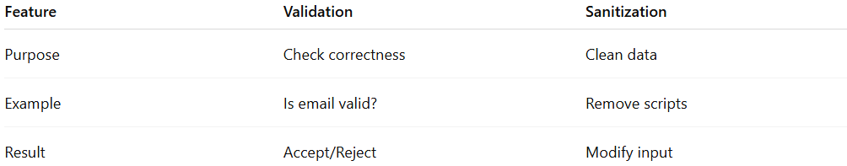
Feature | Validation | Sanitization
Purpose | Check correctness | Clean data
Example | Is email valid? | Remove scripts
Result | Accept/Reject | Modify input

💻 Simple PHP Example
# Source: AI Source: Provided by: [Data Path: Persons Table -> ID Column: 1, Name_En Column: Motasem Essam] -> From: [ChatGPT] on [2/12/2026]
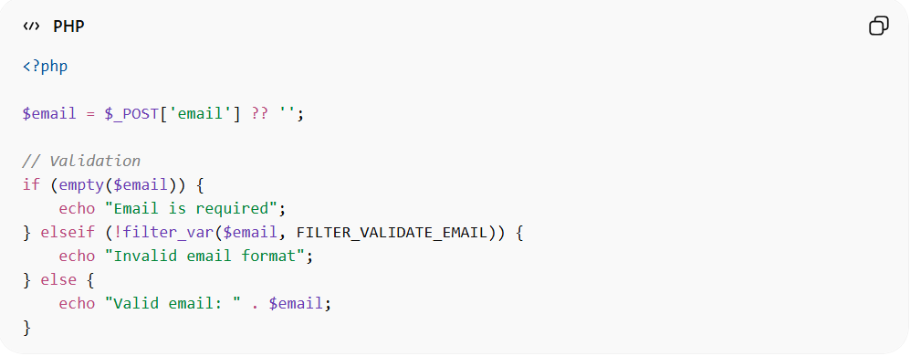
<?php

$email = $_POST['email'] ?? '';

// Validation
if (empty($email)) {
echo "Email is required";
} elseif (!filter_var($email, FILTER_VALIDATE_EMAIL)) {
echo "Invalid email format";
} else {
echo "Valid email: " . $email;
}
● Checks if email exists
● Validates email format
● Accepts only valid input

📦 Example Input
# Source: AI Source: Provided by: [Data Path: Persons Table -> ID Column: 1, Name_En Column: Motasem Essam] -> From: [ChatGPT] on [2/12/2026]
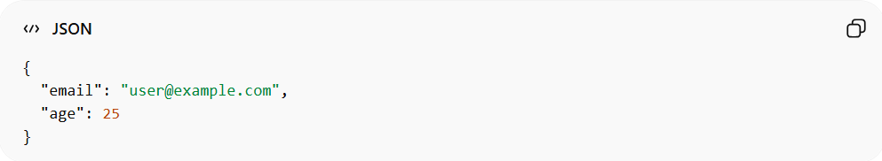
{
"email": "user@example.com",
"age": 25
}
👉 Validation rules:
- email must be valid
- age must be number

🔗 Relation to Other Topics
# Source: AI Source: Provided by: [Data Path: Persons Table -> ID Column: 1, Name_En Column: Motasem Essam] -> From: [ChatGPT] on [2/12/2026]
● Data Input Handling → includes validation
● APIs → validate incoming requests
● Data Formats → define structure
● Security → validation prevents attacks

⚙️ Best Practices
# Source: AI Source: Provided by: [Data Path: Persons Table -> ID Column: 1, Name_En Column: Motasem Essam] -> From: [ChatGPT] on [2/12/2026]
✅ Validate on both client & server
✅ Use built-in validation functions
✅ Return clear error messages
✅ Never trust user input

🎯 Key Idea
# Source: AI Source: Provided by: [Data Path: Persons Table -> ID Column: 1, Name_En Column: Motasem Essam] -> From: [ChatGPT] on [2/12/2026]
👉 Validation = check before use
👉 Only valid data should enter the system

🎓 Final Mental Model
# Source: AI Source: Provided by: [Data Path: Persons Table -> ID Column: 1, Name_En Column: Motasem Essam] -> From: [ChatGPT] on [2/12/2026]
● Input comes from user
● Validation checks it
● Only valid data continues
👉 Garbage in = garbage out ❌
👉 Valid data = reliable system ✅

